20/03/2024

Lesson 62 and 63

Introducing The Git Diff Command

<https://www.canva.com/en_gb/login/?redirect=%2Fdesign%2FDAEVUT6HslA%2FtbdbyITzamUidWfk-HcSug%2Fview>

<https://git-scm.com/docs/git-diff>

Lesson 64

A Guide To Reading Diffs

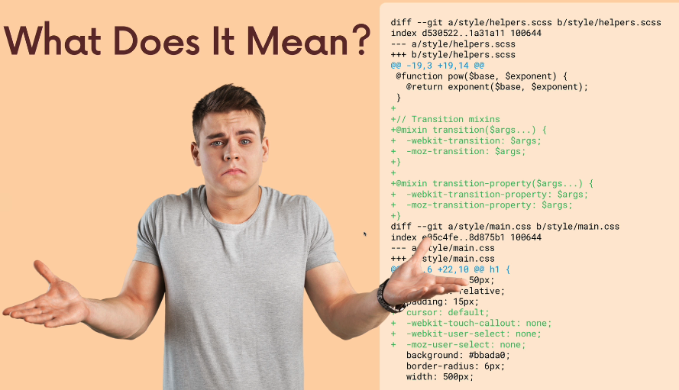

Run the git diff command

This will compare the same file, It will compare the old version and new version of rainbow.

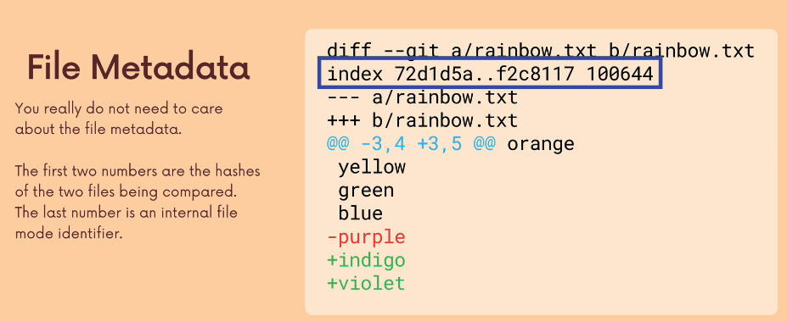

The black text means the content before and after, the red line was the one that was changed and the green is the one that were added. The file might be around 100lines but it will show us around the one that was changed.

Check below for explanation

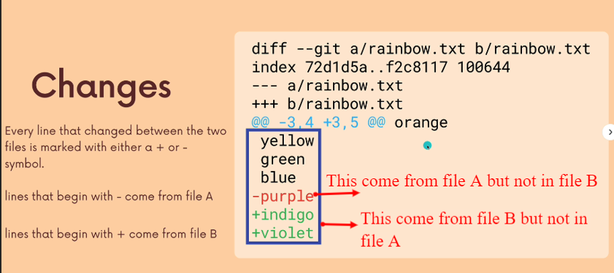

Lesson 64

Viewing Unstaged Changes

Time to use git diff.

Git diff will list all the changes in the working directory that are not stagged.

Lesson 66

Viewing Working Directory Changes

Git diff will list all the changes in the working directory that are not stagged. And since your last commit

Not stagged yet

Because nothing is currently unstagged.

I added and I have not stagged

Lesson 67

Viewing Staged Changes

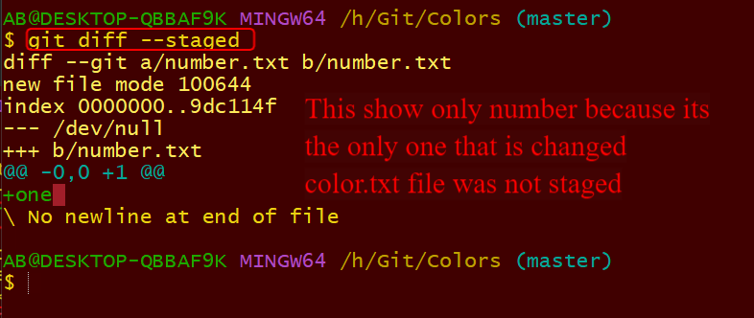

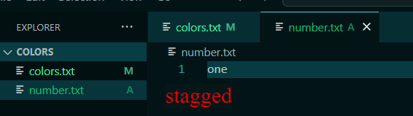

Lesson 68

Diffing Specific Files.

The will show all stage or unstage in this file since my last commit.

Lesson 69

Comparing Changes Across Branches

I commit from the previous video

Now I want to make new branch

I have masters and odd numbers

This is from master to old-numbers

Now I will compare from old -numbers to master.

Lesson 70

Comparing Changes Across Commits

3d97cef 2e86fd9

Lesson 71

Visualizing Diff With Guis

I didn’t do the gitkraker.

Lesson 72

Diff Exercise

https://plum-poppy-0ea.notion.site/Git-Diff-Exercise-f7829bd2783940cea14239022a6c37a9

git clone <https://github.com/Colt/git-diff-exercise>

21/03/2024

Exercise

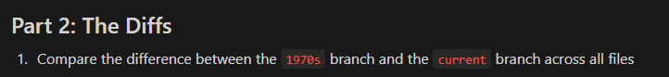

Several ways to do this

Example1

This above is the same as below. The above is new HEAD commit to his Parent HEAD~1

Example 2

The above is parent compare to the chid

Example 3

Copy the hash number and compare

